There are three columns of materials placed randomly in the central material zone: red F-type+S-type material, green F-type+S-type material, blue F-type+S-type material. A robot should move the materials to the construction area, placing the red elements into the first construction area, green elements into the second construction area and blue elements into the third construction area. The task is deemed complete if all the materials are set correctly and the robot stays at the zero position with the accuracy of at least 1.5 mm. Losing or lifting the materials (cubes) again is not allowed during the task. The task should be complete within 120 sec.

Initial scene:

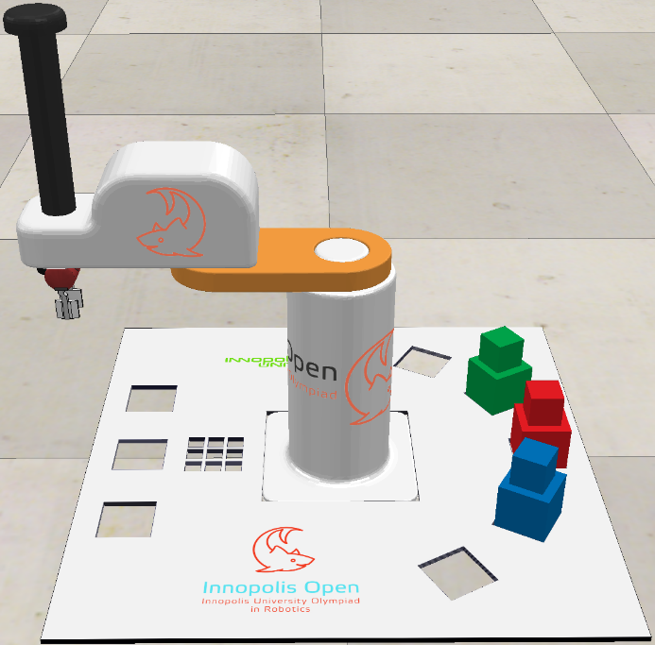

Complete task:

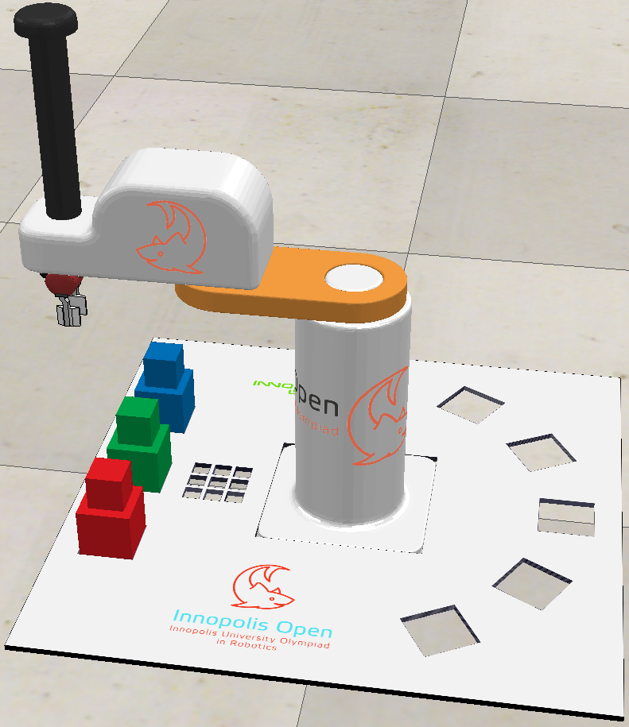

Three files with source code are accepted for answers:

- Child.lua – the source code of the program working in the asynchronous mode;

- Customization.lua - the source code of the program, working in the synchronous (step-by-step with the simulator) mode;

- ManIRS_senior.py – the source code of the robot control program in Python.

The program can be written in one of these files or in several files. The original versions of these files are located in the Programming/Lua and Programming/Python catalogues.